**LEES FARM**

Abstract

Lees farm is a developing area for pets,poultary cages,fish,aquarium,foods,fancy birds,rabbits etc.It is a new application for pets.It is an online project to manage and describe pets.It describe the all information about pets,aquarium,poultary,food etc

Modules

1.Admin

2. Customer

3. Purchase

4. Delivery

Admin

Administrator is the super user and the main controller of the less farm.He/She control all activities of the less farm and has complete authority over the system.

Customer

This module allows to storing customer details such as name, contact, details,address etc.They can purchase items.This module helps to store and maintain a customer profile for current or later use.

Purchase

This module allows to purchase the items and storing the purchasing details.

Delivery Boy

This module allows the delivery details.

**FORM DESIGN**

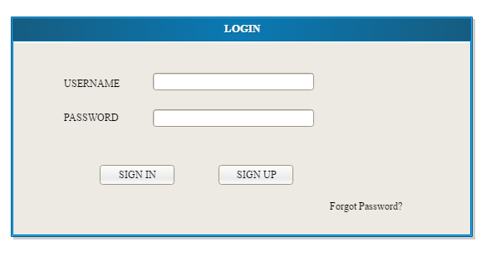

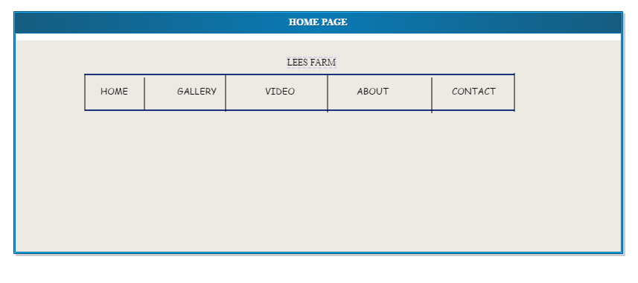

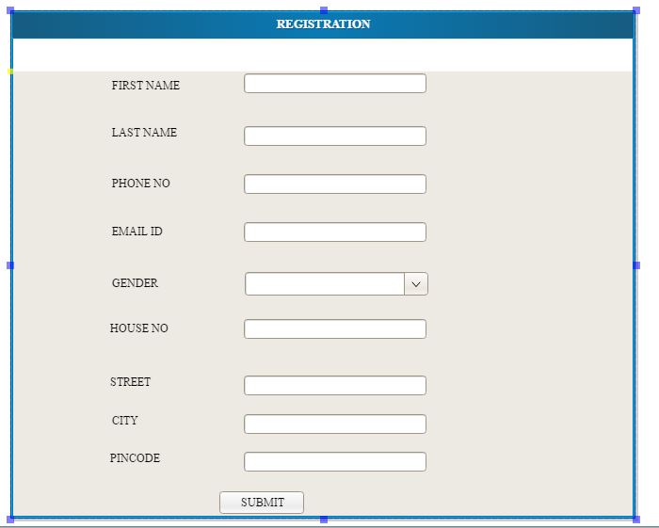

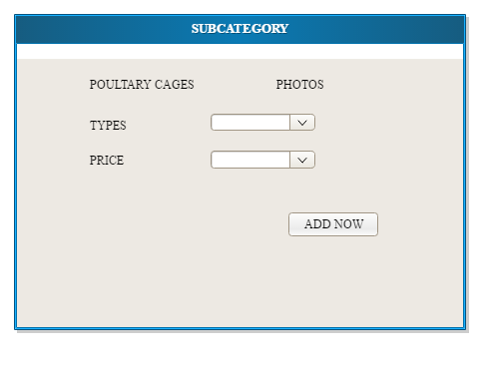

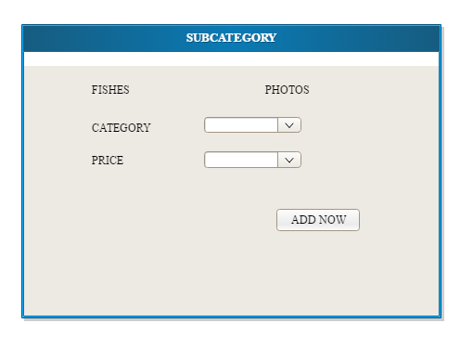

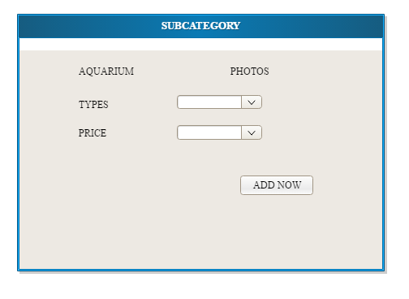

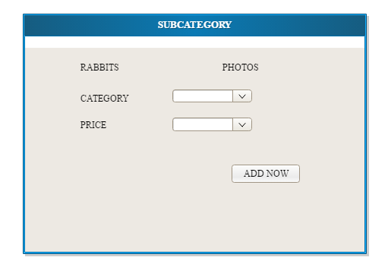

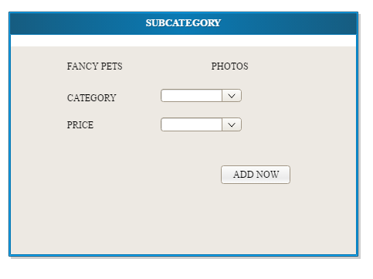

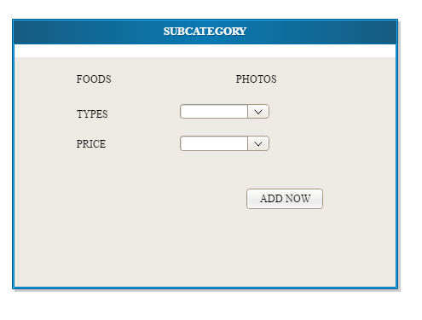

Table Design

1. Table Name: Login

Primary key: Login Id

Foreign key:--

Description: The Information about login

|  |  |  |  |  |
| --- | --- | --- | --- | --- |
| **No** | **Field Name** | **Data Type** | **Constraint** | **Description** |
| 1 | Login_id | int | Primary key | It is store user ID |
| 2 | Username | Varchar(10) | Not null | It store username |
| 3 | Password | Varchar(10) | Not null | It store password |
| 4 | Type | Varchar(10) | Not null | It store type of Admin or Users |
| 5 | status | boolean |  | Approve or reject |

**2**. Table Name: Customers

Primary key: u_ id

Foreign key:--login id

Description: The Information about users

|  |  |  |  |  |
| --- | --- | --- | --- | --- |
| **No** | **Field Name** | **Data Type** | **Constraint** | **Description** |
| 1 | cust_id | int | Primary key | It is store customer ID |
| 2 | login_id | int | foriegnkey | It is store ID |
| 3 | cust_firstName | Varchar(30) | Not null | It store customers first name |
| 4 | cust_fast Name | Varchar(30) | Not null | It store customer Last name |
| 5 | cust_Gender | Varchar(30) | Not null | It store customer gender |
| 6 | cust_Contact No | Numeric (10) | Not null | It store customer Contact no |
| 8 | cust_email_id | Varchar(20) | Not null | It store email id |
| 9 | cust_address | Varchar(20) | Not null | It store customer address |
| 10 | cust_status | Boolean |  | Active or Passive |

**3**. Table Name: Category Details

Primary key: cat_id

Foreign key:--subcat_id

Description: The Information about Category Details

|  |  |  |  |  |
| --- | --- | --- | --- | --- |
| **No** | **Field Name** | **Data Type** | **Constraint** | **Description** |
| 1 | cat _id | Int | Primary key | It store category id |
| 2 | cat_name | Varchar(20) | Not null | It store category name |
| 3 | subcat_id | Varchar(30) | Foreign key | It store subcategory id |
| 4 | cat_age | Integer | Not null | It store category age |
| 5 | cat_type | Varchar(30) | Not null | It store category type |
| 6 | cat_status | Varchar(30) | Not null | Active or passive |

**4.** Table Name: Subcategory

Primary key: subcat_id

Foreign key:--cat_id

Description: The Information about Subcategory

|  |  |  |  |  |
| --- | --- | --- | --- | --- |
| **No** | **Field Name** | **Data Type** | **Constraint** | **Description** |
| 1 | subcat_id | Int | Primary key | It store appointment |
| 2 | cat_id | Varchar(20) | Foreign key | It is store category ID |
| 3 | subcat_name | Varchar(20) | Not null | It store subcategory id |
| 4 | subcat_age | Varchar(30) | Not null | It store age |
| 5 | subcat_type | Varchar(30) | Not null | It store type |
| 6 | subcat_status | Boolean |  | Cancel or Approve |

**5.** Table Name: purchase

Primary key: pro_id

Foreign key:--

Description: The Information about purchase Details

|  |  |  |  |  |
| --- | --- | --- | --- | --- |
| **No** | **Field Name** | **Data Type** | **Constraint** | **Description** |
| 1 | pur_id | Varchar(10) | Primary key | It store purchase Id |
| 2 | cust_id | Varchar(30) | Foreign key | It store customer name |
| 3 | pur_cat | Varchar(30) | Not null | It store purchasing category |
| 4 | pur_type | Varchar(30) | Not null | It store purchase type |
| 5 | pur_date | Varchar(30) | Not null | It store purchase date |
| 6 | pur_status | Boolean |  |  |
|  |  |  |  |  |
|  |  |  |  |  |
|  |  |  |  |  |

TABLE NO: 6

Name: payment

Primary key: pid

Foreignkey: logid reference login

Description:It stores the payment details

|  |  |  |  |
| --- | --- | --- | --- |
| **Field** | **Data type** | **Constraint** | **Description** |
| Pid | int | Primary key | payment id |
| Logid | int | Foreign key | login id |
| Cardtype | varchar | Not null | Card type |
| Cardholdername | varchar | Not null | Card holder name |
| Cardnumber | int | Not null | Card number |
| Totalamount | int | Not null | Total amount |

TABLE NO: 7

Name: cart

Primary key: cartid

Foreignkey: logid reference login and orderid reference order

Description:It stores the cart details

|  |  |  |  |
| --- | --- | --- | --- |
| **Field** | **Data type** | **Constraint** | **Description** |
| Cartid | int | Primary key | Order id |
| Logid | int | Foreign key | login id |
| orderid | int | Foreign key | Item id |
| Quantity | int | Not null | Quantity |
| Price | int | Not null | price |

TABLE NO: 8

Name: order

Primary key: orderid

Foreignkey: logid reference login and itemid reference item

Description:It stores the order details

|  |  |  |  |
| --- | --- | --- | --- |
| **Field** | **Data type** | **Constraint** | **Description** |
| Orderid | Int | Primary key | Order id |
| Logid | Int | Foreign key | login id |
| Itemid | Int | Foreign key | Item id |
| Quantity | Int | Not null | Quantity |
| Price | int | Not null | price |
| Date | Date | Not null | Date |

TABLE NO: 9

Name: category

Primary key: catid

Description:It stores the category of items

|  |  |  |  |
| --- | --- | --- | --- |
| **Field** | **Data type** | **Constraint** | **Description** |
| catid | int | Primary key | category id |
| Category name | varchar | Not null | Category name |
| Status | Varchar | Not null | Status |

**TABLE NO: 10**

Name: delreg

Primary key: did

Foreignkey: logid reference login

Description:It stores the deliveryboy details

|  |  |  |  |
| --- | --- | --- | --- |
| **Field** | **Data type** | **Constraint** | **Description** |
| did | Int | Primary key | Delivery boy id |
| Logid | Int | Foreign key | login id |
| name | Varchar | Not null | Name |
| Contact no | int | Not null | Contact no |
| location | varchar | Not null | Location |
| Email id | varchar | Not null | Email id |

TABLE NO: 11

Name: feedback

Primary key: fid

Foreignkey: logid reference login

Description:It stores the feedback

|  |  |  |  |
| --- | --- | --- | --- |
| **Field** | **Data type** | **Constraint** | **Description** |
| fid | Int | Primary key | It is store the feedback id |
| Logid | int | Foreign key | It store the login id |
| Username | Varchar | Not null | It store the username |
| Feedback | Varchar | Not null | It strore the feedback |

